Sean Yang

1/10/18

Pd 4

Journal 13

I started a basic GUI for my project. I would like to add a video display window for live camera feed for the capture script. It’s possible, but it requires converting numpy array to PIL image and displays it in Tkinter. It should still be fast enough though.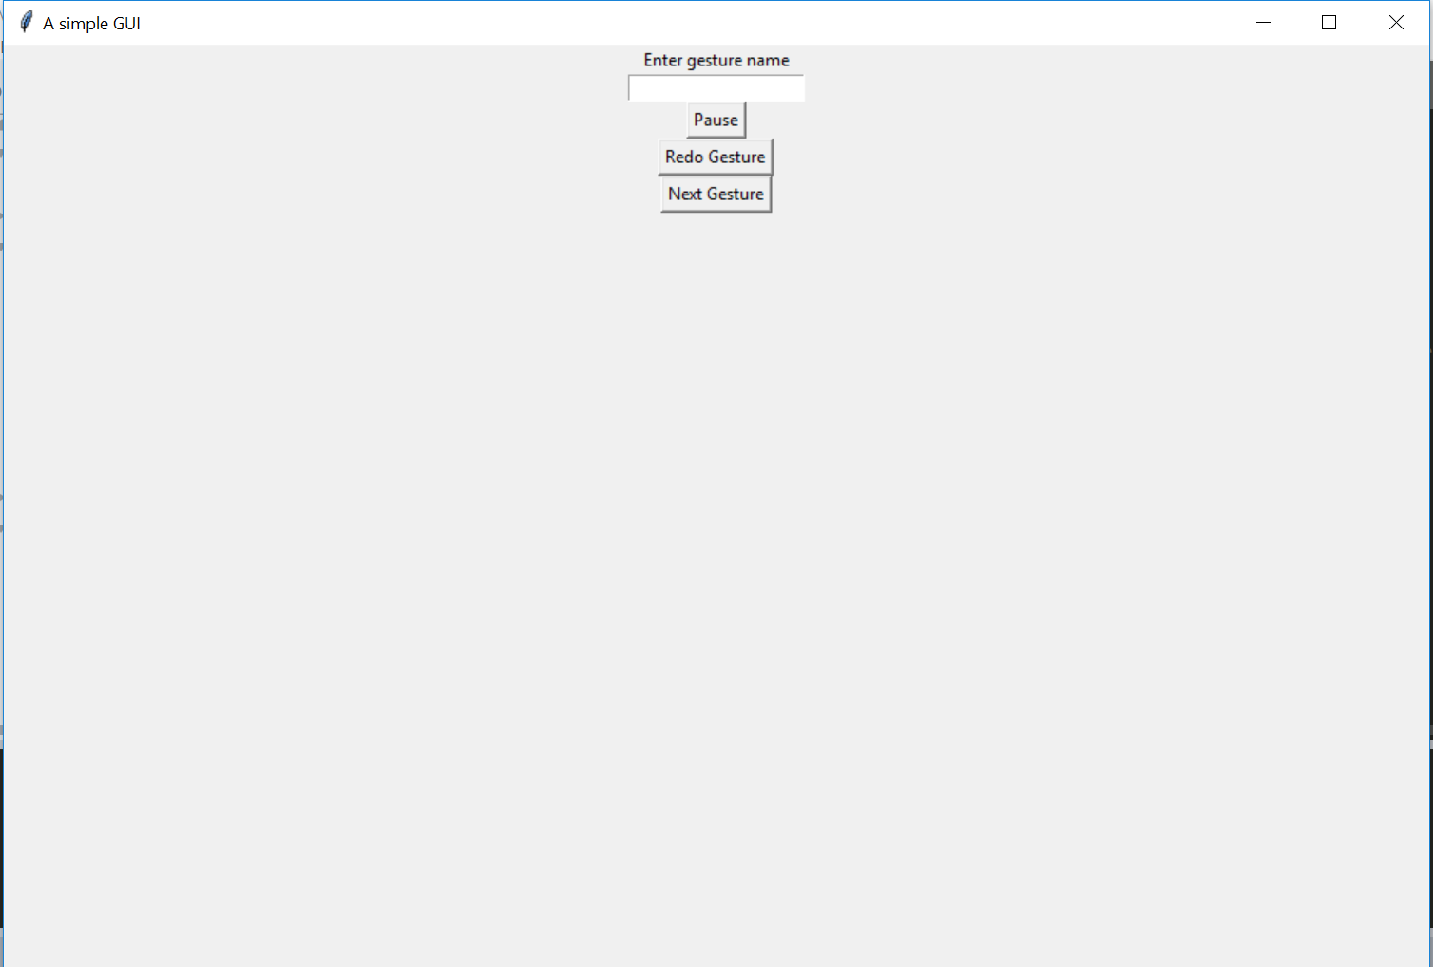

I thought everything could be done with flask for the web component, but I actually need html and javascript to handle my front end. It took me a while to understand the web component of my project. I did quite a bit of reading on web basic knowledge. I talked to Evan Shi and he pointed me in the right direction. He said to use a flask server to take images, process it, and send it back. He uses webrtc to capture the video stream. Then the images get parsed to a flask endpoint and information get sent back to the server.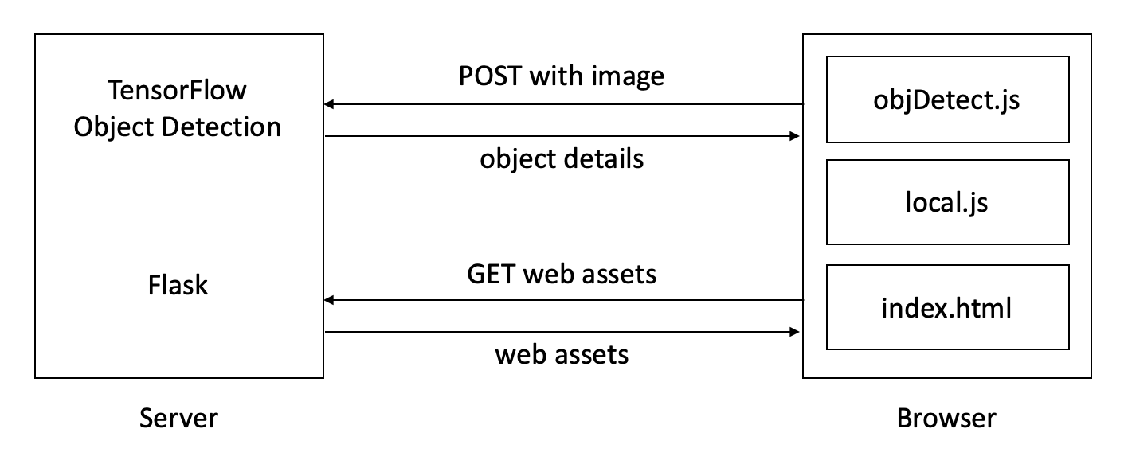

Since I don’t know front end very well, I copied Evan’s website and plan to modify it later. I had problems with directory and file paths. Initially when I did href path set as /static/some.js. For some reason, html couldn’t find the file. After changing the path to ./static/some.js it works.

This quarter I will first focus on web demo and GUI. After that I will work on making the classifier better. Currently, my page asks for permission for the camera. The camera light lights up. However, it doesn’t display the video back and I’m not sure how to handle it with flask completely. I suspect that the website is trying sending the video information to the flask endpoint, but nothing is sent back. I should be able to figure it out by the end of the next week though.